**PDP PROJECT SPECIFICATION 2016**

|  |  |  |
| --- | --- | --- |
| **Names of Students in Group** | **Course** | **Student Number** |
| Gergely Daku - Programmer | Game Software Development | B5021985 |
| Laurence Brown - Programmer | Game Software Development | B5033698 |
| Dom Hodgkiss - Artist | Games Design | B5007719 |
| Gabriella Wray - Artist | Games Design | B5018391 |
| Daniel Higgins - Artist | Games Design | B5020496 |

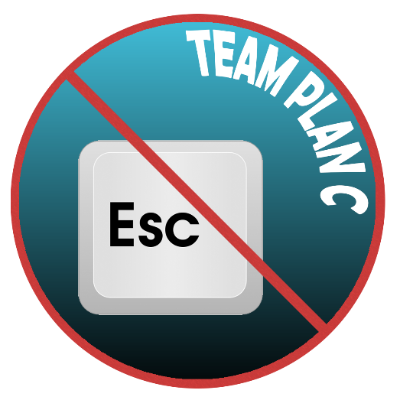**GROUP NAME:** Team Plan C

**GROUP LETTER:** L

**TITLE OF PROJECT**: Full On Space Potato

(Previous name was “project space brick”)

**DESCRIPTION OF THE PROJECT**

2.5D space ship flying game in the asteroid belt of Saturn. Using general Xbox controller input layout. Main gameplay is fly, shoot, mine, trade and explore.

**PROJECT OBJECTIVES**

* Pilot space ship through asteroid field
* Mine asteroids and sell the cargo at the nearby station
* Destroy enemy ships
* Explore space
* Complete missions
* Have fun!

**PROJECT DELIVERABLE**

A 2.5D arcade style space game built in Unity. The player will use an Xbox controller to pilot the ship and interact with the surroundings. Space stations need to be discovered first to show up on the map. Two factions will rule the asteroid belt. Enemy ships and enemy stations will try to eliminate the player. Missions will be offered at the stations. On successful mission completion, the player will be able to choose one award from a range of options. Overall goal is to defeat the enemy faction by destroying enemy ships and overtaking stations.

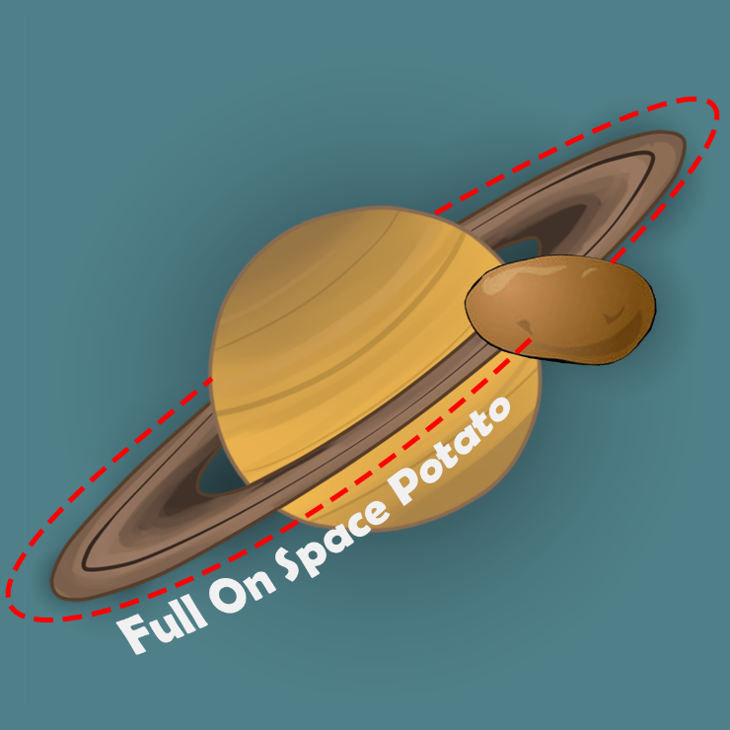**SOFTWARE NEEDED**

* Unity
* 3Ds Max/Maya
* Photoshop
* Sound editing software
* Visual Studio

**TECHNICAL SKILLS**

Programmers – using Unity (with Mono Develop)

* Create scripts for all requirements of the game
* Optimise game for best performance

Artists – using 3D modelling software of choice and Photoshop

* Creating low poly style 3D models
* UI and GUI textures
* Animation (if necessary)

**PREPARATION FOR THE BLOCK TEACHING WEEK**

* Programmers will need to focus on coding all the functionalities of the game, fixing bugs and improving overall gameplay experience.
* Artists will need to provide all the assets like 3D models, textures and maybe animations.
* In the final few days, everyone has to focus on improving the game by either visually or by performance.

|  |  |  |
| --- | --- | --- |
| Days | Programmers | Artists |
| Monday | Getting all features ready | Creating all assets |
| Tuesday | Getting all features ready | Creating all assets |
| Wednesday | Getting all features ready | Creating all assets |
| Thursday | Bug fixing and play testing | play testing, improving asset quality |
| Friday | Bug fixing and play testing | play testing, improving asset quality |